Agile Lab Fat
Name:- P. Manush Royal
Reg-No:- 23MIS0341
Clone Repo:-
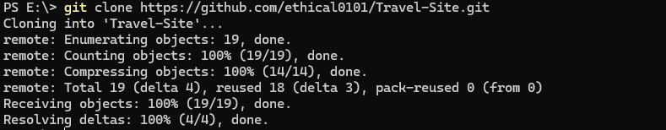
Showing Commits History :-
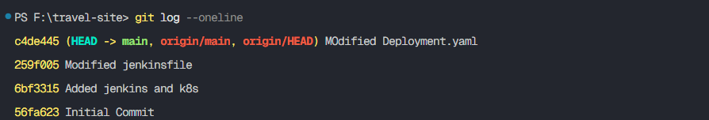
Project Structure:-
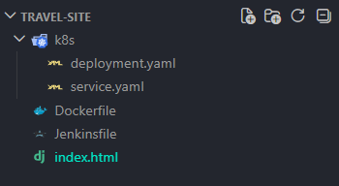
Index.html
<!DOCTYPE html>
<html>
<head>
<title>ABC Tours & Travels</title>
<style>
body { font-family: Arial; margin: 0; }
header { background: #0077b6; color: white; padding: 15px; text-align: center; }
nav { background: #023e8a; padding: 10px; text-align: center; }
nav a { color: white; margin: 10px; text-decoration: none; font-weight: bold; }
section { padding: 20px; }
footer { background: #03045e; color: white; text-align: center; padding: 10px; }
</style>
</head>

<body>

<header>
<h1>ABC Tours & Travels</h1>
</header>

<nav>
<a href="#home">Home</a>
<a href="#destinations">Destinations</a>
<a href="#packages">Packages</a>
<a href="#about">About</a>
<a href="#contact">Contact</a>
</nav>

<section id="home">
<h2>Welcome</h2>
<p>Explore the best travel destinations!</p>
</section>

<section id="destinations">
<h2>Destinations</h2>
<h3>Goa</h3>
<p>Beaches, nightlife - ₹10,000</p>

<h3>Ooty</h3>
<p>Hill station - ₹8,000</p>

<h3>Hampi</h3>
<p>Heritage site - ₹6,000</p>
</section>

<section id="packages">
<h2>Packages</h2>
<ul>
<li>Weekend - ₹5000</li>
<li>Family - ₹12000</li>
<li>Luxury - ₹25000</li>
</ul>
</section>

<section id="about">
<h2>About Us</h2>
<p>We provide best travel services.</p>
</section>

<section id="contact">
<h2>Contact</h2>
<p>Email: abc@gmail.com</p>
<p>Phone: 9876543210</p>
</section>

<footer>
<p>© 2026 ABC Tours</p>
</footer>

</body>
</html>
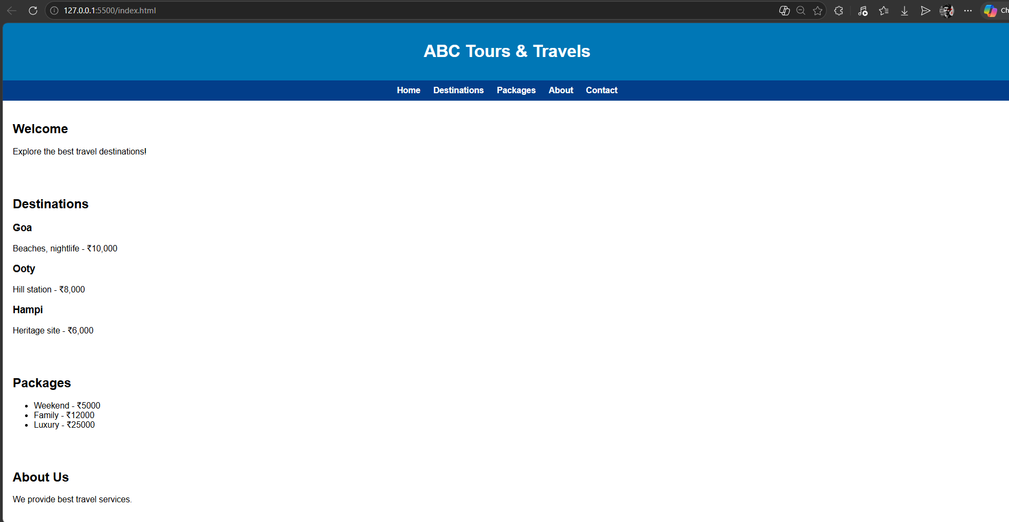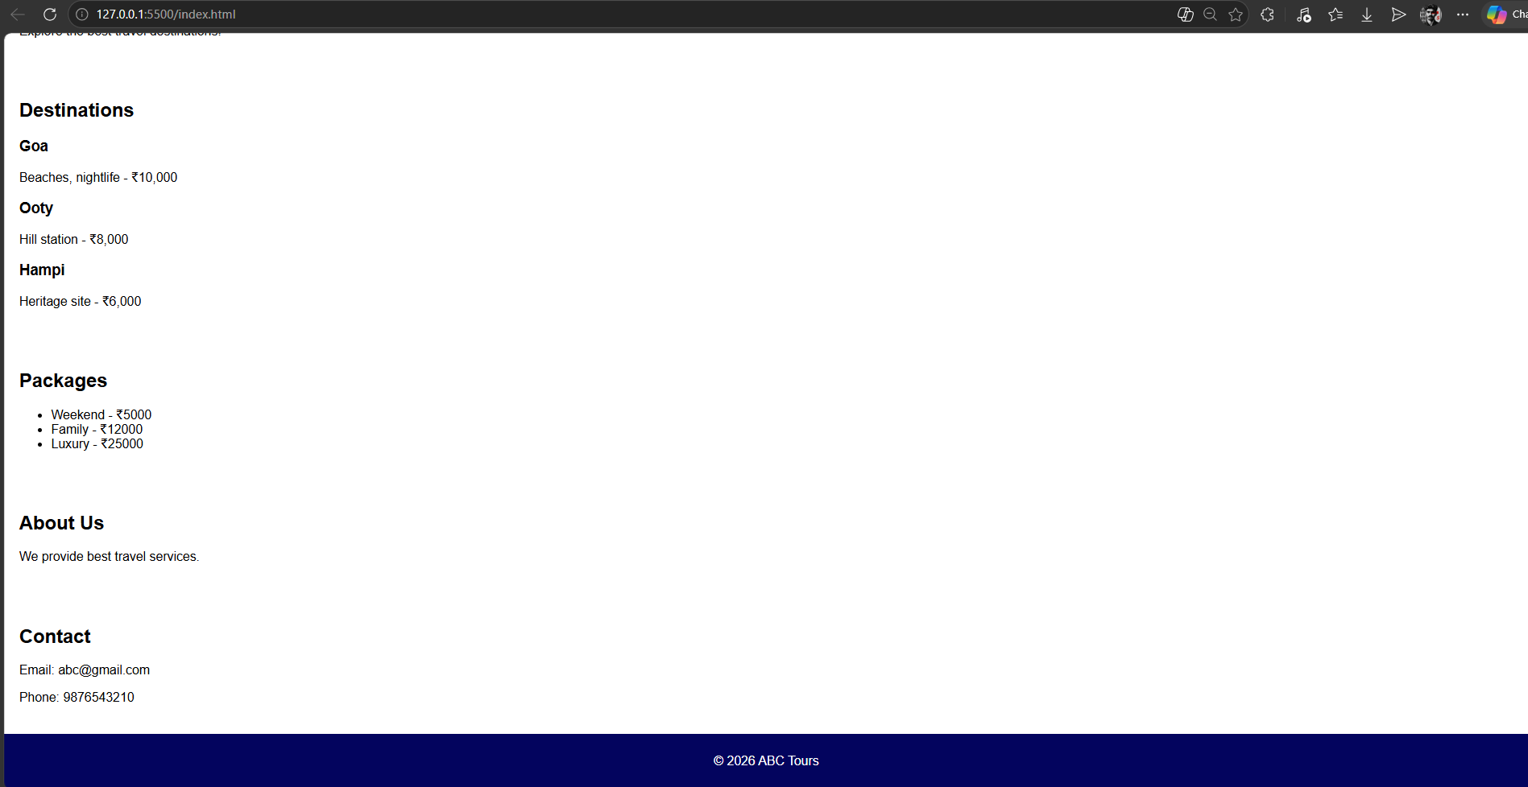
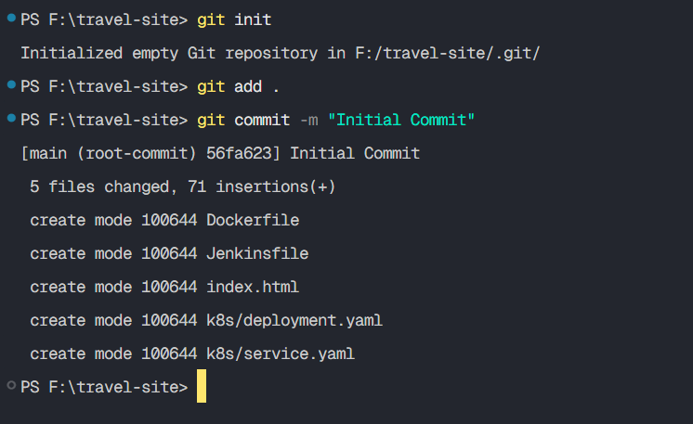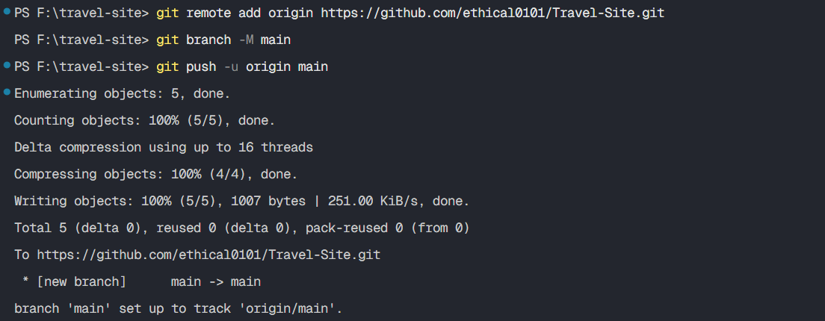

Docker Build:-
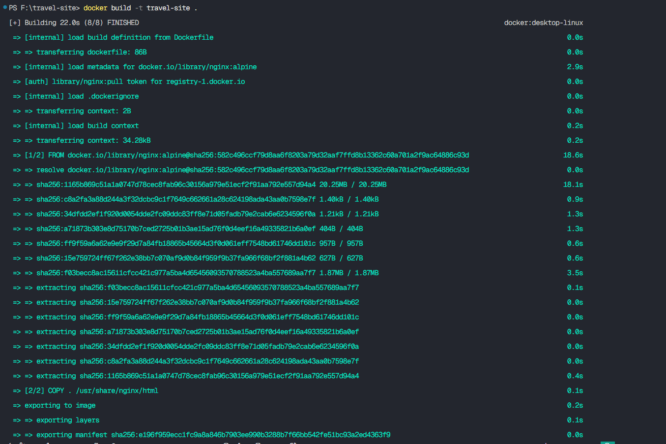
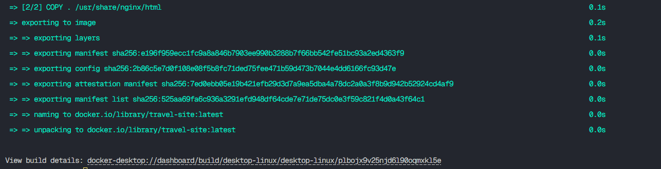
Running the docker image:-
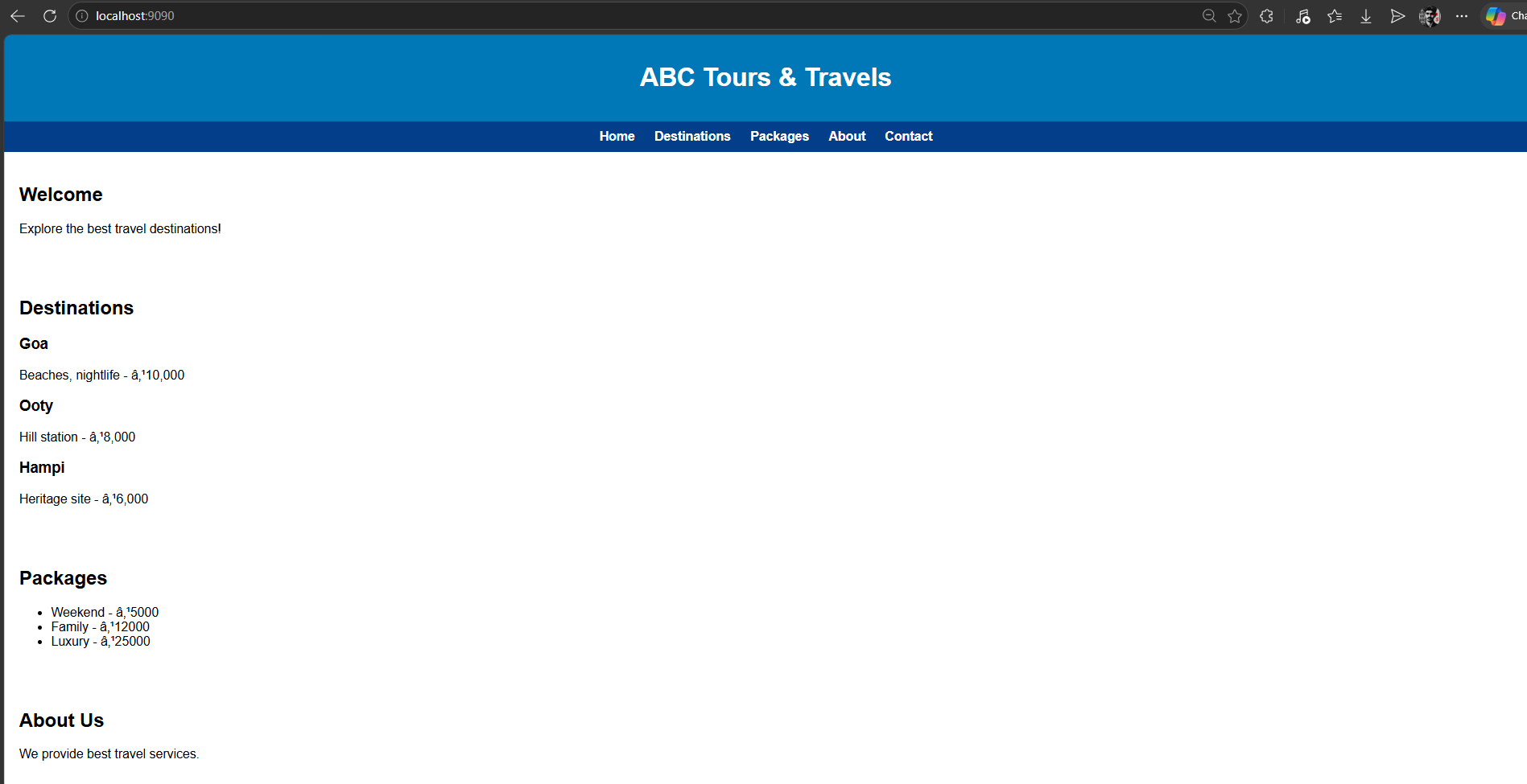
Configuring Jenkins:-
pipeline code:-

pipeline {
agent any

stages {

stage('Clone Code') {
steps {
git branch: 'main', url: 'https://github.com/ethical0101/Travel-Site.git'
}
}

stage('Build Docker Image') {
steps {
bat 'docker build -t travel-site .'
}
}

stage('Stop Old Container') {
steps {
bat 'docker stop travel-container || exit 0'
bat 'docker rm travel-container || exit 0'
}
}

stage('Run Container') {
steps {
bat 'docker run -d -p 9090:80 --name travel-container travel-site'
}
}
}
}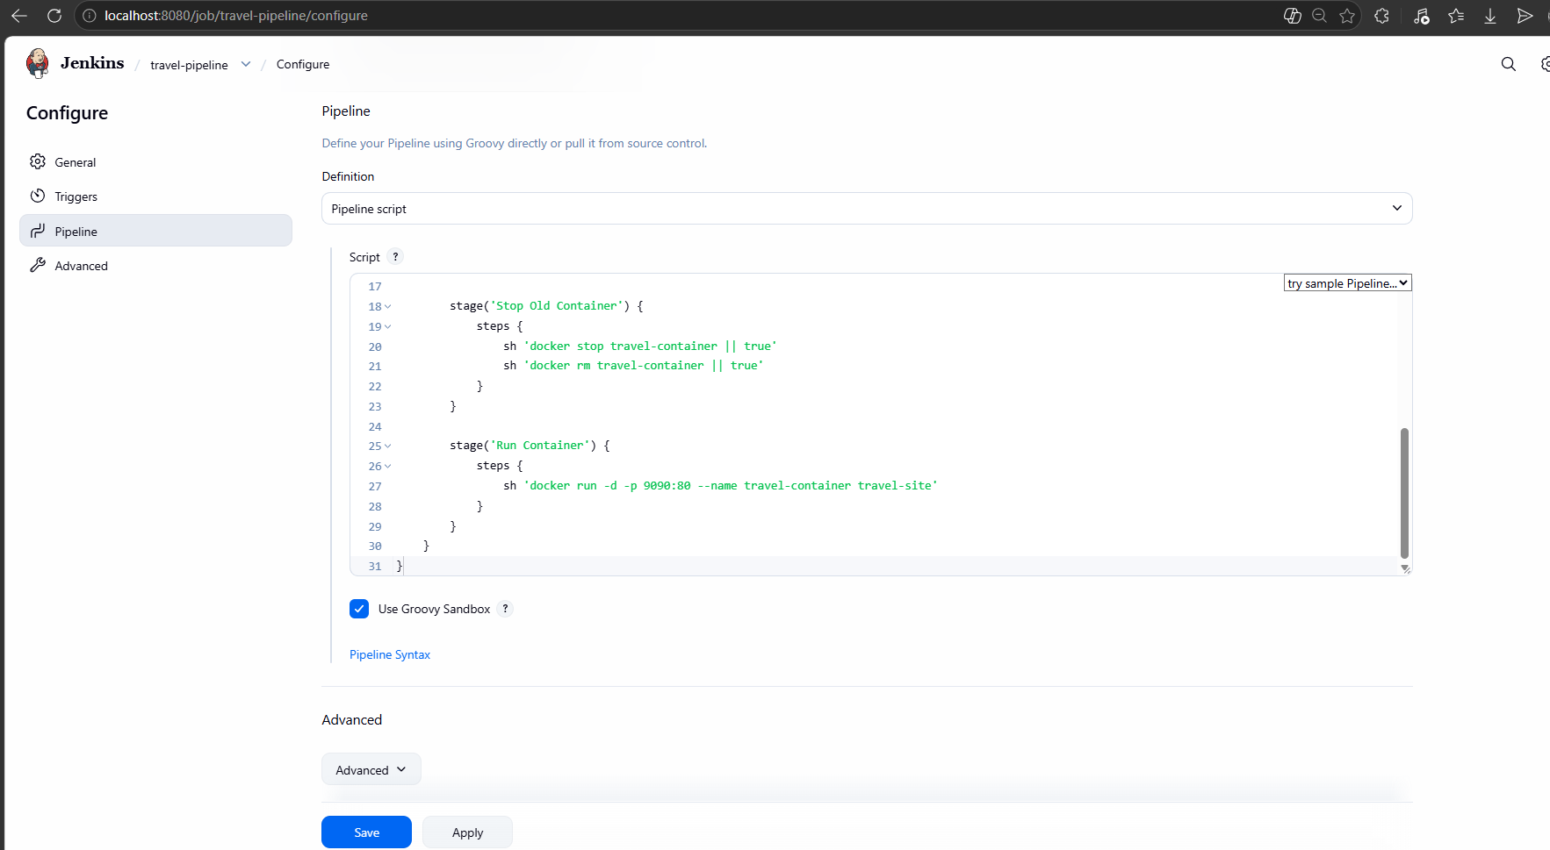
deployment.yaml:-
apiVersion: apps/v1
kind: Deployment
metadata:
name: travel-app
spec:
replicas: 2
selector:
matchLabels:
app: travel
template:
metadata:
labels:
app: travel
spec:
containers:
- name: travel-container
image: travel-site
ports:
- containerPort: 80
service.yaml:-
apiVersion: v1
kind: Service
metadata:
name: travel-service
spec:
type: NodePort
selector:
app: travel
ports:
- port: 80
targetPort: 80
nodePort: 30007

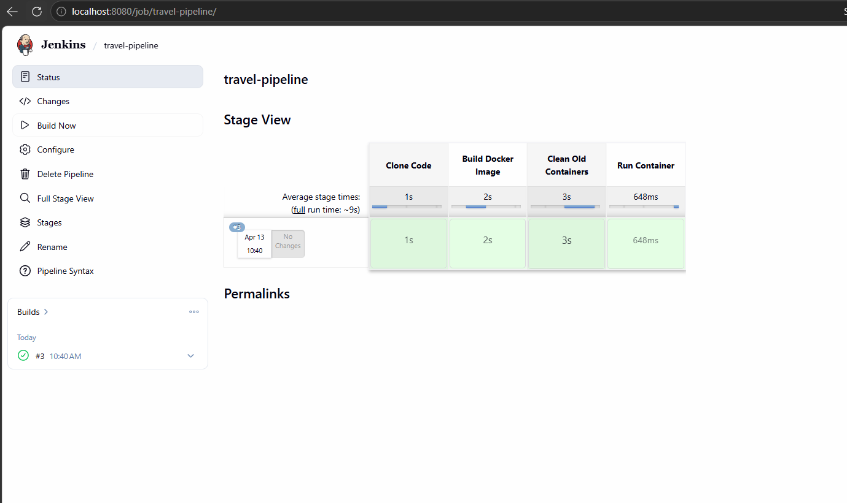
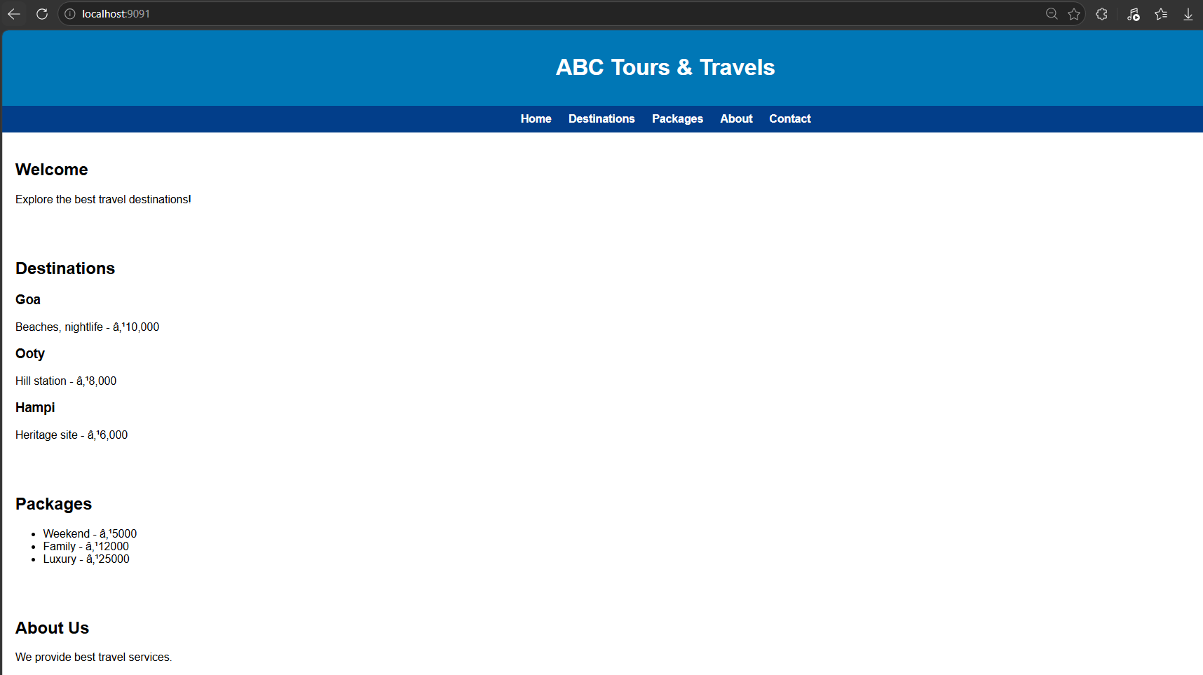
Docker config:-
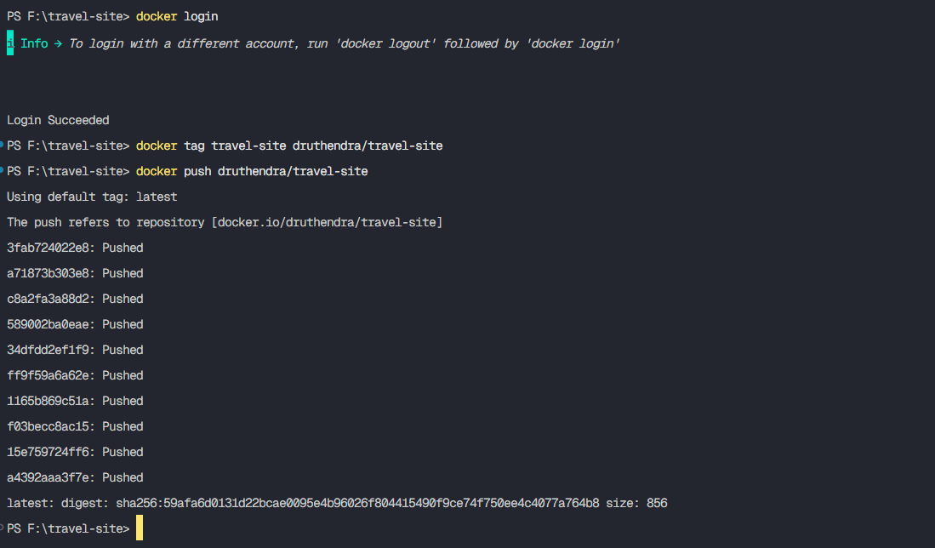
Applying Kubernetes:-
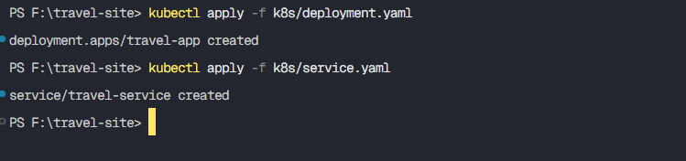
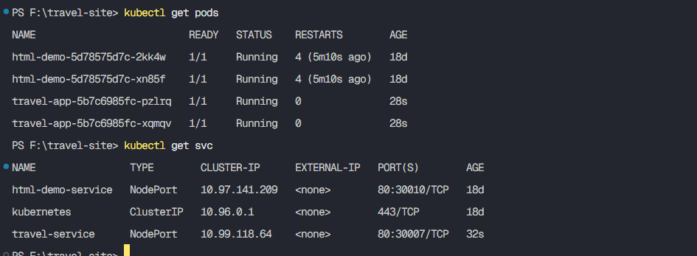
Accessing the web page at port 30007
